# Correct Order to Define and Backtest a Trading Strategy with bt

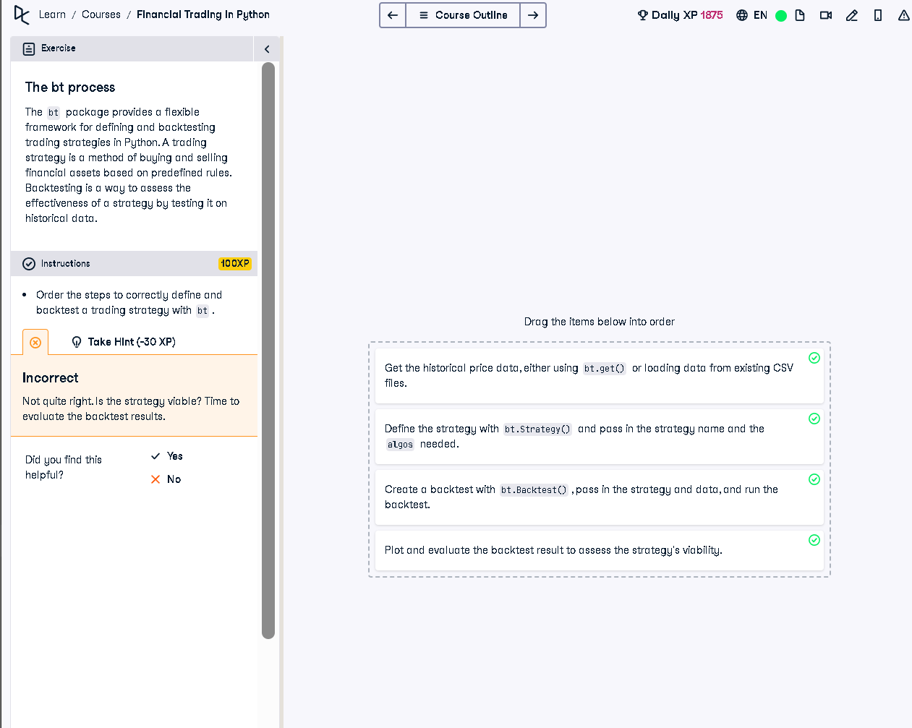

## Correct Order of Steps (Python Explanation)

1. Get the historical price data, either using bt.get() or loading data from existing CSV files.

2. Define the strategy with bt.Strategy() and pass in the strategy name and the algos needed.

3. Create a backtest with bt.Backtest(), pass in the strategy and data, and run the backtest.

4. Plot and evaluate the backtest result to assess the strategy's viability.

## Simple 50-Word Explanation

To test a trading strategy in Python using bt, you first load the historical price data. Then, define your strategy logic. Next, create a backtest combining the strategy and data. Finally, run and analyze the results using plots to determine if the strategy performs well historically.